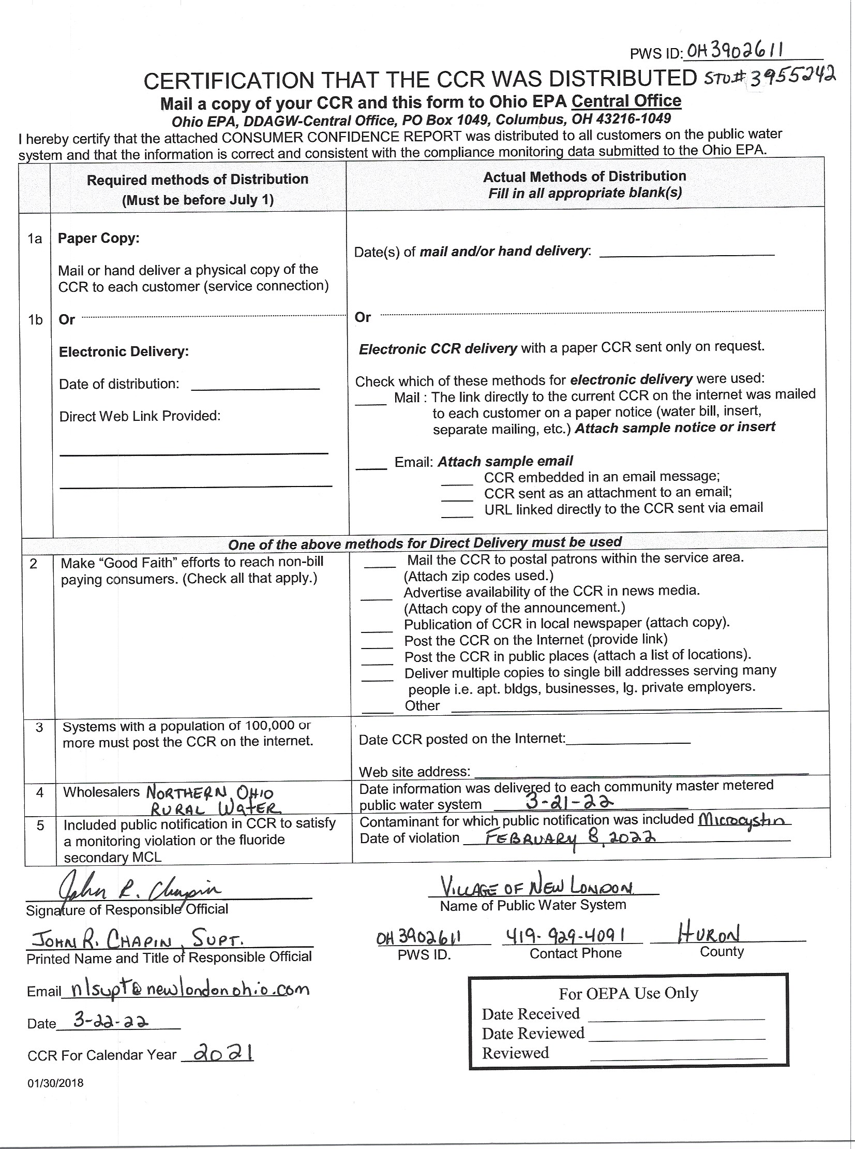Village of New London Water Plant OH3902611 (3955242)

Drinking Water Consumer Confidence Report
For 2021

Section 1: Introduction
The Village of New London has prepared the following report to provide information to you, the consumer, on the quality of our drinking water. Included within this report is general health information, water quality test results, how to participate in decisions concerning your drinking water and water system contacts. We have a current, unconditioned license to operate our water system.

Section 2: Source Water Information.
The Village of New London pumps water into the New London Reservoir from Buck Creek, a branch of the Vermilion River. The reservoir has a surface area of 220 acres, when full, and has a volume of 1.4 billion gallons. The average daily production of safe drinking water for 2021 was 354,000 gallons for the approximately 1360 customers we have. The Village of New London also has an emergency, auxiliary or back-up connection with Rural Lorain County Water Authority. An emergency, auxiliary or back-up connection is defined as a connection not meant to be used on a continuous basis and is only used during extraordinary conditions such as drought, source failure, line breaks, fires, and other periods of usually high-water demands. During 2021 the emergency back-up connection was not used. This report does not contain information on the water quality from R.L.C.W.A. but a copy of their consumer confidence report can be obtained by contacting them at: Rural Lorain County Water Authority, 42401 SR 303, P.O. Box 567, Lagrange, Ohio 44050 or calling 800-842-1339.
The Ohio EPA compiled a Drinking Water Source Assessment Report for the Village of New London with the assistance of John Chapin, Supt. Of Water, intended to identify drinking water protection areas and provide information on how to reduce the risk of contamination of the water within those areas. A copy of this report may be obtained by contacting the Village of New London (419)-929-4091.
For the purposes of source water assessments, all surface waters, are considered to be susceptible to contamination. By their nature surface waters are accessible and can be readily contaminated by chemicals and pathogens, with relatively short travel times from source to the intake. Based on the information compiled for this assessment, the Village of New London drinking water source protection area is susceptible to agricultural runoff, confined animal feedlots, pasture, silage, pesticide/ fertilizer/ petroleum storage, above ground storage tanks, industrial storm water, gas line rupture, gas station runoff, home construction runoff, feed lot runoff, marina boat docks, furniture repair and refinishing, unsewered areas, and truck fleet terminals.
It is important to note that this assessment is based on available data, and therefore may not reflect current conditions in all cases. Water quality, land uses and other activities that are potential sources of contamination may change with time. While the source water for the Village of New London Public Water System is considered susceptible to contamination, historically, the Village of New London Public Water System has effectively treated this source water to meet drinking water quality standards.

Section 3: What are sources of contamination to drinking water?
The sources of drinking water both tap water and bottled water includes rivers, lakes, streams, ponds, reservoirs, springs, and wells. As water travels over the surface of the land or through the ground, it dissolves naturally occurring minerals and, in some cases, radioactive material, and can pick up substances resulting from the presence of animals or from human activity. Contaminants that may be present in source water include: (A) Microbial contaminants, such as viruses and bacteria, which may come from sewage treatment plants, septic systems, agricultural livestock operations and wildlife; (B) Inorganic contaminants, such as salts and metals, which can be naturally-occurring or result from urban storm water runoff, industrial or domestic wastewater discharges, oil and gas production, mining, or farming; (C) Pesticides and herbicides, which may come from a variety of sources such as agriculture, urban storm water runoff, and residential uses; (D) Organic chemical contaminants, including synthetic and volatile organic chemicals, which are by-products of industrial processes and petroleum production, and can also come from gas stations, urban storm water runoff, and septic systems; (E) radioactive contaminants, which can be naturally-occurring or be the result of oil and gas production and mining activity. PFAS: Per- and polyfluoroalkyl substances (PFAS) are a group of man-made chemicals applied to many industrial, commercial and consumer products to make them waterproof, stain resistant, or nonstick. PFAS are also used in products like cosmetics, fast food packaging, and a type of firefighting foam called aqueous film forming foam (AFFF) which are used mainly on large spills of flammable liquids, such as jet fuel. PFAS are classified as contaminants of emerging concern, meaning that research into the harm they may cause to human health is still ongoing.

In order to ensure that tap water is safe to drink, USEPA prescribes regulations which limit the amount of certain contaminants in water provided by public water systems. FDA regulations establish limits for contaminants in bottled water, which must provide the same protection for public health. Drinking water, including bottled water, may reasonably be expected to contain at least small amounts of some contaminants. The presence of contaminants does not necessarily indicate that water poses a health risk. More information about contaminants and potential health effects can be obtained by calling the Environmental Protection Agency’s Safe Drinking Water Hotline (1-800-426-4791).

Section 4: Who needs to take special precautions?
Some people may be more vulnerable to contaminants in drinking water than the general population. Immunocompromised persons such as persons with cancer undergoing chemotherapy, persons who have undergone organ transplants, people with HIV/AIDS or other immune system disorders, some elderly, and infants can be particularly at risk from infection. These people should seek advice about drinking water from their health care providers. EPA/CDC guidelines on appropriate means to lessen the risk of infection by Cryptosporidium and other microbial contaminants are available from the Safe Drinking Water Hotline (1-800-426-4791).

Section 5: About your drinking water.
The EPA requires regular sampling to ensure drinking water safety. The Village of New London conducted sampling for bacteria, turbidity, pH, chlorine, alkalinity, hardness, inorganics, nitrates, synthetic organics, volatile organics, total organic carbon, total trihalomethanes, haloacetic acids, dissolved organic compounds, cryptosporidium, e-coli, lead and copper. Samples were collected for a total of 190 different contaminants most of which were not detected in the New London water supply. The Ohio EPA requires us to monitor for some contaminants less than once per year because the concentrations of these contaminants do not change frequently. Some of our data, though accurate, is more than one year old.

Section 6: Table of Detected Contaminants
Listed below is information on those contaminants that we found in the Village of NL’s drinking water.

TABLE OF DETECTED CONTAMINANTS
Contaminants (Units) | MCLG | MCL | Level Found |  | Range of Detections | Violation |  | Sample Year |  | Typical Source of Contaminants
Turbidity (NTU)
Turbidity (%meeting standard) |  |  | 0.20 NTU  100% |  | 0.04-0.20 NTU  100% | No  No |  | 2021  2021 |  | Soil Runoff
Residual Disinfectants
Total Chlorine (ppm) | MRDL=4 | MRDLG=4 | 1.60 ppm |  | 1.28-1.73  ppm | No |  | 2021 |  | Water additive used to control microbes
Inorganic Contaminants
Fluoride (ppm) | 4.0 | 4.0 | 0.80 ppm |  | 0.80-1.15  ppm | No |  | 2021 |  | Erosion of natural deposits; Water additive, which promotes strong teeth; Discharge from fertilizer and aluminum factories
Barium (ppm) | 2.0 | 2.0 | 0.0307 ppm |  | n/a | No |  | 2021 |  | Discharge of drilling wastes; discharge from metal refineries; erosion of natural deposits
Nitrate (ppm) | 10 | 10 | .62 ppm |  | .15-.62  ppm | No |  | 2021 |  | Runoff from fertilizer use; leaching from septic tanks, sewage; erosion of natural deposits sewage;
Lead and Copper
Contaminants (units) | Action Level (AL) | Individual Results over the AL |  | 90% of test levels were less than |  |  | Violation |  | Year Sampled |  | Typical source of Contaminants
Lead (ppb) | 15 ppb | 0 |  | June-Sept.  1 ug/L |  |  | No |  | 2021 |  | Corrosion of household plumbing systems
Lead (ppb) | 0 out of 10 samples were found to have lead levels in excess of the lead action level of 15 ppb.
Copper (ppm) | 1.3 ppm | 0 |  | June-Sept.  .157 mg/L |  |  | No |  | 2021 |  | Corrosion of household plumbing systems; Erosion of natural deposits; Leaching from wood preservatives
Copper (ppm) | 0 out of 10 samples were found to have copper levels in excess of the copper action level of 1.3 ppm.

Volatile Organic Contaminants
Total Trihalomethanes | n/a | 80ppb |  | 32.2-78.9  ppb | No | 2021 | By-product of drinking water chlorination
Haloacetic Acids | n/a | 60ppb |  | 21.2-40.5  ppb | No | 2021 | By-product of drinking water chlorination
TOC | n/a | TT | n/a | n/a | No | 2021 | Naturally present in the environment

Section 7: Turbidity is a measure of the cloudiness of water and is an indication of the effectiveness of our filtration system. Turbidity has no health effects; however, turbidity can interfere with disinfection and provide medium for microbial growth. Turbidity may indicate the presence of disease-causing organisms. These organisms include bacteria, viruses, and parasites that can cause symptoms such as nausea, cramps, diarrhea, and can be associated with headaches. The turbidity limit set by the EPA is 0.3 in 95% of the daily samples and shall not exceed 1.0 NTU at any time. As reported above the Village of New London’s highest recorded turbidity result for 2021 was 0.20 NTU and lowest monthly percentage of samples meeting the turbidity limits was 100%.
Total organic carbon (TOC) has no health effects; however, it does provide a medium for the formation of disinfection by-products. These by-products include trihalomethanes (TTHM) and haloacetic acids (HAA5’s). Some people who drink water containing TTHM’s in excess of the MCL over many years may experience problems with their liver, kidneys, or central nervous systems, and may have an increased risk of getting cancer.
Barium: Some people who drink water containing barium in excess of the MCL over many years could experience an increase in their blood pressure.
If present, elevated levels of lead can cause serious health problems, especially for pregnant women and young children. Lead in drinking water is primarily from materials and components associated with service lines and home plumbing. The Village of New London is responsible for providing high quality drinking water but cannot control the variety of materials used in plumbing components. When your water has been sitting for several hours, you can minimize the potential for lead exposure by flushing your tap for 30 seconds to 2 minutes before using water for drinking or cooking. If you are concerned about lead in your water, you may wish to have your water tested. Information on lead in drinking water, testing methods, and steps you can take to minimize exposure is available from the Safe Drinking Water Hotline at 800-426-4791or at http://www.epa.gov/safewater/lead.

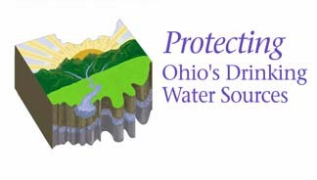

Drinking Water Source Assessment for the Village of New London

SUMMARY

Source Water Assessment and
Protection. The following report for the Village of New London was compiled as part of the Source Water Assessment and Protection Program for Ohio. This program is intended to identify drinking water protection areas and provide information on how to reduce the risk of contamination of the waters within those areas. The goal of the program is to ensure the long-term availability of abundant and safe drinking water for the present and future citizens of Ohio.
The Safe Drinking Water Act Amendments of 1996 established the national Source Water Assessment and Protection Program, targeting drinking water sources for all public water systems in the United States. A public water system is a facility that provides drinking water to 15 or more service connections or that regularly serves at least 25 people a day for at least 60 days a year, whether from an underground well or spring, or from an above ground stream, lake, or reservoir. The requirement does not address residential wells or cisterns. In Ohio there are approximately 5,800 public water systems.
Background. The Village of New London operates a community public water system that serves a population of approximately 3,200 (Plant #1) and 10,100 (Plant #2) people. The source is surface water taken from Buck Creek. The system’s treatment capacity is approximately 1,300,00 gallons per day, but current average production is about 877,000 gallons per day.
Protection Areas. The drinking water source protection area for the surface water source is shown in the following figure. This report includes the results of an inventory of all known or identified potential contaminant sources within the drinking water protection area. The inventory was conducted by Ohio EPA with the assistance of John Chapin,
Superintendent of the Village of New London Water Treatment Plant. Possible threats to the surface water source include agricultural runoff, pasture, above ground storage tanks, industrial storm water, gas line rupture, marina boat docks, unsewered areas, cemeteries, oil and gas wells, roadways, and railways.
Protective Strategies. The goal of source water assessment is implementation of protective strategies that will better protect the drinking water source. Strategies for protecting Buck Creek should include controlling runoff from agricultural areas, establishment of an early warning and emergency response plan for spills, controlling home and commercial septic system discharges from failing systems, coordination with local emergency response agencies, and evaluation of the potential impacts from wastewater treatment plant sludge application within the protection area.
The Village of New London and other jurisdictions comprising the protection areas are encouraged to develop a local protection plan to protect the source of
drinking water or to update current emergency management plans as applicable. Local watershed planning efforts may already be underway to guide stream restoration and protection activities. These efforts can also serve to benefit the protection of drinking water sources. Guidance on how to form a Drinking Water Protection Team and protection plan is available from Ohio EPA by calling (614) 644-2752.
For More Information. Additional information on protective strategies and how this assessment was completed is included in the detailed Drinking Water Source Assessment Report for the Village of New London.
For information on how to obtain a copy of this report, please visit Ohio EPA’s Source
Water Assessment and Protection Program Web page at http://www.epa.state.oh.us/ddagw/pdu/ swap.html or contact the Village of New London for a copy.
Current information on the quality of the treated water supplied by the Village of New London is available in the Consumer Confidence Report (CCR) for the Village of New London Public Water System. The CCR is distributed annually and reports the most current detected contaminants and any associated health risks from data collected during the past five years. Consumer Confidence Reports are available from the Village of New London.
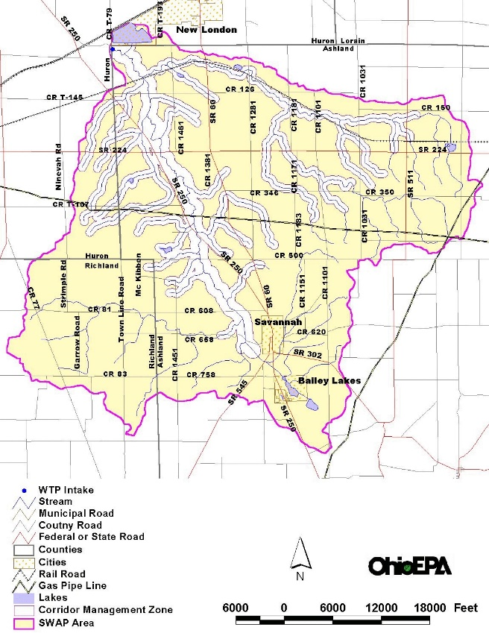
Summary Figure. Drinking Water Source Protection (SWAP) Area for the Village of New London.

Section 8: Definitions of some terms contained within this report.
Maximum Contaminant Level Goal (MCLG): The level of a contaminant in drinking water, below which there is no known or expected risk to health. MCLGs allow for a margin of safety.

Maximum Contaminant level (MCL): The highest level of contaminant that is allowed in drinking water. MCLs are set as close to the MCLGs as feasible using the best available treatment technology.

Parts per Million (ppm) or Milligrams per Liter (mg/L) are units of measure for concentration of a contaminant. A part per million corresponds to one second in a little over 11.5 days.

Parts per Billion (ppb) or Micrograms per Liter (μg/L) are units of measure for concentration of a contaminant. A part per billion corresponds to one second in 31.7 years.

Maximum Residual Disinfectant Level Goal (MRDLG): The level of drinking water disinfectant below which there is no known or expected risk to health. MRDLGs do not reflect the benefits of the use of disinfectants to control microbial contaminants.

Maximum Residual Disinfectant Level (MRDL): The highest level of a disinfectant allowed in drinking water. There is convincing evidence that addition of a disinfectant is necessary for control of microbial contaminants.

Action Level (AL): The concentration of a contaminant, which if exceeded, triggers treatment or other requirements, which a water system must follow.

Treatment Technique (TT): A required process intended to reduce the level of a contaminant in drinking water.

The “<” symbol: A symbol which means less than. A result of <5 means that the lowest level that could be detected was 5 and the contaminant in that sample was not detected.

TOC value reported: The value reported under “Level Found” for Total Organic Carbon (TOC) is the lowest ration between percentage of TOC actually removed to the percentage of TOC required to be removed. A value of greater than one (1) indicates that the water system is in compliance with TOC removal requirements. A value of less than 1 indicates a violation of the TOC removal requirements.

Section 9: How do I participate in decisions concerning my drinking water?
Public participation and comment are encouraged at regular meetings of the New London Village Council, which meets on the second and fourth Monday of every month at 7:00p.m. in the New London Community Center and Council Chambers at the Village Office, 115 E. Main St., New London, Ohio. For more information on your drinking water contact: John R. Chapin, Water Superintendent (419) 929-8419. You can view the 2021 CCR at www.newlondonohio.com/ccr.html or request a paper copy at (419) 929-4091.

Section 10: Violations
DRINKING WATER NOTICE

Microcystins monitoring requirements not met for NEW LONDON VILLAGE water system

We are required to monitor your drinking water for specific contaminants on a regular basis. Results of regular monitoring are an indicator of whether or not our drinking water meets health standards. During the week of 1/23/22-2/5/22 we did not monitor for microcystins and therefore cannot be sure of the quality of our drinking water during that time.

What Should I Do?
This notice is to inform you that NEW LONDON VILLAGE public water system did not monitor, and report results for the presence of microcystins in the public drinking water system during the week of 1123/22-215/22 monitoring period, as required by the Ohio Environmental Protection Agency. You do not need to take any action in response to this notice.
What is being done?
upon being notified of this violation, the water supply was required to have the drinking water analyzed for total microcystins according to their current monitoring schedule. The water supplier will take steps to ensure that adequate monitoring will be performed in the future.
A sample was (will be) collected on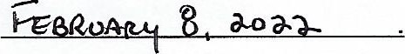
Sample results and additional information may be obtained by contacting NEW LONDON VILLAGE at:
Contact Person:
Phone Number: 419-929-4091
Mailing Address: 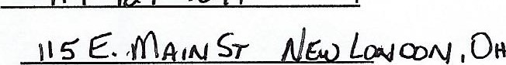 '-14851
Please share this information with all the other people who drink this water, especially those who may not have received this notice directly (for example, people in apartments, nursing homes, schools and businesses). You can do this by posting this notice in a public place or distributing copies by hand or mail.
PWSID: 01-13902611 Facility ID: 3955242
Date Distributed:

Tier 3: Monitoring Violation Notice

